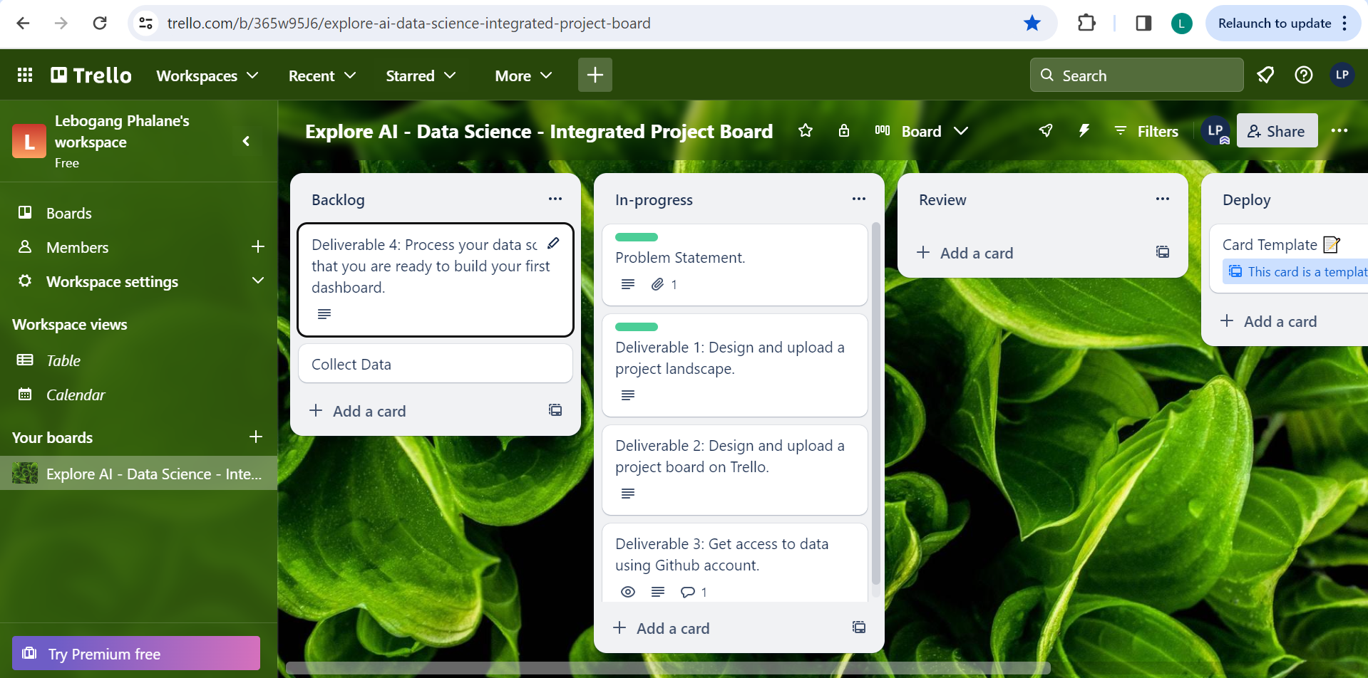**17 November 2023 – Trello Board (In Progress)**